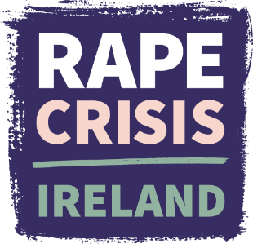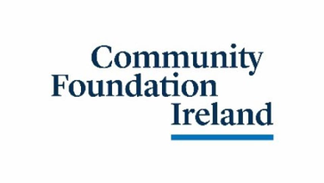

Application form for Rape Crisis Ireland’s Specialist Sexual Violence Training for Accredited Counsellors

Personal details
Name:
Email:
Address (optional):
Mobile no.:
Name of Rape Crisis Centre (or other organisation) you work for:

Professional background
What professional qualification in counselling/psychotherapy do you hold (including name of accrediting body)?
What year did you qualify?
Please outline your experience working as a counsellor/psychotherapist to date:

Do you currently work with survivors of sexual violence? If yes, in what context or setting?

Practical commitment
This training runs over 9 months. Group work is core to the training; we therefore require commitment to that process and attendance at all weekends is expected. Are you able to commit to this schedule? If you anticipate any circumstances that might affect your ability to attend consistently, please let us know so we can discuss if an accommodation is possible.

Personal statement
Please write a personal statement (up to 600 words) outlining why you wish to participate in this training, including your suitability and what you would like to gain from the course. We would encourage you to share any relevant professional or life experiences you feel strengthen or should be considered in your application. This may form discussion between you and the course trainers but will remain confidential to the course trainers and the intake panel

Reference
Please provide the name and contact details of one professional referee (e.g. clinical supervisor or manager) who can speak to your suitability for this training.

How did you hear about the training?

Are you happy for us to contact you by phone in connection with your application, should this be required as part of our selection process? Yes / No

Please return your completed application form to training@rcni.ie by Monday 31st August 2026.
Rape Crisis Ireland will process the information provided in this form to assess your application. Information may be shared with external course trainers for the purpose of assessment and course delivery. Aggregated, non-identifiable statistics (e.g. number of applicants, attendance or completion rates) may be shared with funders or as part of our impact reporting; you will not be personally identified in this reporting. Your personal statement will be treated as confidential to the course trainers and intake panel. For more on how we handle your data, you can contact our Data Protection Officer on data@rcni.ie.

